

**“GOOGLE ASSISTANT BASED AUTOMATION”**

SUBMITTED BY:

**GOVINDRAJ C S (1NH18EC040)**

Under the guidance of

**Dr.SANJEEV SHARMA**

Head of Department, Dept. of ECE, NHCE, Bengaluru.

# C:\Documents and Settings\Students\Local Settings\Temporary Internet Files\Content.Word\download (1).jpg

# NEW HORIZON COLLEGE OF ENGINEERING

(ISO-9001:2000 certified, Accredited by NAAC ‘A’, Autonomous college permanently affiliated to VTU)Outer Ring Road, Panathur Post, Near Marathalli, Bengaluru-560103

## NEW HORIZON COLLEGE OF ENGINEERING

## DEPARTMENT OF ELECTRONICS AND COMMUNICATION ENGINEERING



**CERTIFICATE**

Certified that the mini project work entitled “**Google Assistant based Automation**” carried out by **ANVS Manideep(1NH18EC012), G Sai Sandeep (1NH18EC033), Chandra Mohan P (1NH18EC024), Govindraj C S (1NH18EC040),** Bonafede students of Electronics and Communication Department , New Horizon College of Engineering, Bangalore.

The mini project report has been approved as it satisfies the academic requirements in respect of mini project work prescribed for the said degree.

Project Guide HOD ECE

Dr.SANJEEV SHARMA Dr.SANJEEV SHARMA

**External Viva**

Name of Examiner Signature with Date

1.

2.

**ACKNOWLEDGEMENT**

The satisfaction that accompany the successful completion of any task would be, but impossible without the mention of the people who made it possible, whose constant guidance and encouragement helped us succeed.

We thank **Dr. Mohan Manghnani**, Chairman of **New Horizon Educational Institution**, for providing necessary infrastructure and creating good environment.

We also record here the constant encouragement and facilities extended to us by **Dr.Manjunatha**, Principal, NHCE and **Dr. Sanjeev Sharma**, head of the department of Electronics and Communication Engineering. We extend sincere gratitude to them.

We sincerely acknowledge the encouragement, timely help and guidance to us by our beloved guide **Dr. Sanjeev Sharma** to complete the project within stipulated time successfully.

Finally, a note of thanks to the teaching and non-teaching staff of electronics and communication department for their co-operation extended to us, who helped us directly or indirectly in this successful completion of mini project.

**GOVINDRAJ C S (1NH18EC040)**

**TABLE OF CONTENTS**

ABSTRACT

**CHAPTER 1**

INTRODUCTION…………………………………………………………………………………7

**CHAPTER 2**

LITERATURE SURVEY…………………………………………………………………………8

**CHAPTER 3**

PROPOSED METHODOLOGY…………………………………………………………………..12

**CHAPTER 4**

PROJECT DESCRIPTION ………………………………………………………………………..14

4.1 HARDWARE DESCRIPTION………………………………………………………………16

4.2 SOFTWARE DESCRIPTION…………………………………………………………………22

**CHAPTER 5**

WORKING……………………………………………………………………………………....27

**CHAPTER 6**

6.1. ADVANTAGES…………………………………………………………………………….28

6.2. LIMITATIONS……………………………………………………………………………..28

**CHAPTER 7**

RESULTS AND DISCUSSION……………………………………………………………….29

**CHAPTER 8**

CONCLUSION AND FUTURE SCOPE …………………………………………………………32

REFERENCES…………………………………………………………………………………….36

**LIST OF FIGURES**

|  |  |  |  |
| --- | --- | --- | --- |
| **SL**  **No** | **FIGURE**  **No** | **FIGURE DESCRIPTION** | **Page**  **No** |
| 1. | 2.5.1 | Reality Home Automation | 11 |
| 2. | 3.1 | Block Diagram | 12 |
| 3. | 4.1 | Interfacing Diagram of NODEMCU(ESP8266) with Ralay module | 15 |
| 4. | 4.2 | NODEMCU (ESP8266) Development Board | 16 |
| 5. | 4.3 | Pin Diagram of Node MCU | 18 |
| 6. | 4.4 | Channel Relay | 21 |
| 7. | 4.5 | Google assistant | 23 |
| 8. | 4.6 | Arduino edit window | 26 |
| 9. | 7.1 | Outputs | 31 |

### LIST OF TABLES

|  |  |  |  |
| --- | --- | --- | --- |
| **SL**  **No** | **Table**  **No** | **TABLE DESCRIPTION** | **Page**  **No** |
| 1 | 4.1 | Pin description of 4-Channel Relay | 22 |
|  |  |  |  |

**ABSTRACT**

The idea behind Google Assistant-based automation is to control home devices throughvoice.In this project, the voice commands used by Google Assistance with the help of Google's free Cloud-based IoT web server, which is used to create virtual switches, IFTTT (If it is linked to create a conditional if else statement. Voice commands have been added.Google Assistant through the IFTTT website. In this automation, when the user gives commands to the Google Assistant, the devices such as the refrigerator, fan, light bulb, etc., are controlled accordingly.The commands given to the Google assistant are decoded and received by the microcontroller, the microcontroller in turn controls the relay that is connected to it. The devicesconnected to the respective relay can be turned on and off according to the command given by the user through the Google Assistant. NODEMCU (8266) present in the microcontroller that facilitates communication between the devices and the microcontroller via Wi-Fi.

CHAPTER 01

**INTRODUCTION**

Home automation refers to automatic and electronic devices to control appliances, functions, activities and devices. The functions, utilities and features of our house can be easily controlled via Wi-Fi (Internet). The three main elements of the automation system are: sensors, controllers and actuators. The ultimate goal of the technology is to increase efficiency and reduce effort. In this fashionable world, IoT is gaining importance. Automation leads to much efficiency and less effort. With the help of IoT, we have managed to control devices in several areas, one of which is the control of home automation by the node microcontroller. We can also use other microcontroller boards like raspberry pi, Arduino, etc. In today’s technology all work is done through communication so the effective means of communication can be done through voice. It is mainly aimed at people with physical disabilities and the elderly. The user’s speech will be taken as the input by the microphone. The microphone recognizes the person’s speech and sends it to the recognition module. If the command (ON/OFF) is given, the action is performed. As we know that people come home tired after a long day at work. Some are too tired to have a hard time moving once they land on their couch, sofa or bed. So, any little gadget/tech that helps them turn their lights on or off, or listen to their favorite music, etc. with your voice using your smart phones, it would make your home more comfortable. IOT applications have become so popular in the 21st century due to dominant use of the internet, the evolution of smartphone technology, and the rise in the level of mobile communications.

**CHAPTER 02**

**LITERATURE SURVEY**

**2.1) Bluetooth based home automation system using mobile phones:** In Bluetooth based home automation system, devices are connected to the Arduino BT board at the input and output ports through a relay. The Arduino BT board program is based on a high level interactive C language of microcontrollers; the connection is made via bluetooth. Password protection is provided so that only the authorized user can access the devices. The Bluetooth connection is established between the Arduino BT board and the phone for wireless communication. In this system, Python script is used and it can be installed in any environment of Symbian operating system, it is portable. A circuit is designed and implemented to receive feedback from the phone, which indicates the status of the device.

**2.2) Zigbee based home automation system using mobile phones:** To monitor and control household appliances, the system is designed and implemented using Zigbee. Network coordinators record and store the performance of devices. For this, the Wi-Fi network is used, which uses the modern standard wireless ADSL router with four switch ports. Network SSID and Wi-Fi security settings are preconfigured. The message for security purposes is first processed by the virtual home algorithm and when declared secure, it is re-encrypted and transmitted to the actual home network device. Through the Zigbee network, the Zigbee controller sent messages at the end. The security and protection of all messages received by the virtual house algorithm. To reduce the system expenses and the intrusion of the installation of the respective system, Zigbee communication is useful.

**2.3) GSM based home automation system using mobile phones:** Due to mobile telephony and GSM technology, GSM based home automation is attracting research. Home automation based on SMS, home automation based on GPRS and home automation based on two-tone multifrequency (DTMF), these options are mainly considered for GSM communication. The figure shows the logic diagram of the work of A. Alheraish, it is shown how sensors and home devices interact with the home network and communicate through GSM and SIM (subscriber identity module). The system uses a transducer which converts the function of the machine into electrical signals which go to the microcontroller. The sensors in the system convert physical qualities like sound, temperature and humidity to another quantity like voltage. The microcontroller analyzes all signals and converts them into commands to be understood by the GSM module. Select the appropriate communication method between SMS, GPRS and DTFC according to the command received by the GSM module.

**2.4) Wi-Fi home automation system using mobile phones:** The Wi-Fi home automation system mainly consists of three modules, the server, the hardware interface module and the software package. The figure shows the design of the system model. The server and the hardware interface module use Wi-Fi technology to communicate with each other. The same technology is used to connect to the server's web application. The server is connected to the Internet, so remote users can access the server's web application over the Internet using a supported web browser. The latest home automation system software is divided into server application software and microcontroller (Arduino) firmware. Arduino software, built in C language, using IDE comes with the microcontroller itself. Arduino software is responsible for collecting events from connected sensors, then applying the action to actuators and preprogramming it on the server. Another job is to report and save the history in the server database. The server application package for the proposed home automation system is a web application built with asp.net. The server application software can be accessed from the internal network or from the Internet if the server has a real IP address on the Internet using an Internet browser that supports asp.net technology. The server application software is responsible for the maintenance of the entire home automation system, installation and configuration. The server uses the database to keep the home automation system component record, we choose to use XML files to save the system record.

**2.5) Home automation with RF module -** The important objective of home automation system is to build a home automation system using an RF remote control. Now that technology accelerates, homes are also getting smarter. Modern homes are deliberately switching from current switches to the centralized control system, which contains switches controlled by RF. These days, traditional wall switches located in various parts of the house cause the end user to take time to approach them to control and operate them. More so, it becomes more problematic for the elderly or the disabled to do so. Home automation through remote use implements a simpler solution with RF technology. To do this, an RF remote control is associated with the microcontroller on the transmitter side which sends ON / OFF signals to the receiver where the devices are connected. By operating the remote switch indicated on the transmitter, loads can be globally turned on / off using wireless technology

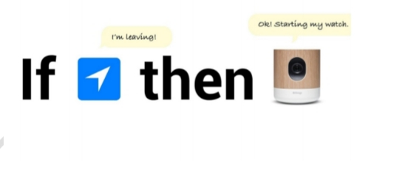

Fig 2.5.1 Reality Home Automation

CHAPTER 03

**PROPOSED METHODOLOGY**

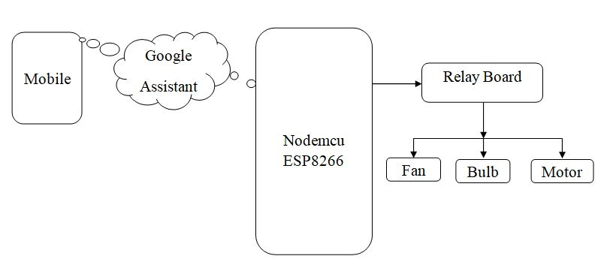

**Fig 3.1** Block Diagram

The procedure for implementing the project is as follows:

We will be using Node MCU as the main component. We will preconfigure the commands in the IFTTT web application which in turn is connected to the webhooks, then to the Blynk server, then to the Node MCU over Wi-Fi. This proposed system eliminates the cabling complication in the case of wired automation. . A considerable power supply is also possible. The operating range is more than Bluetooth. The existing system does not allow remote monitoring and control of devices. But while, in the proposed system, the system which uses the home automation system based on Wi-Fi makes it possible to monitor and control the devices. The home automation system that existed in the 1990s, people in every household have electronic devices that are controlled manually, but in our proposed system, we control all devices remotely.

**CHAPTER 04**

**PROJECT DESCRIPTION**

For home automation controlled by the Google Assistant, the user must first have an Android phone with the Google Assistant installed. When the user gives commands to the Google Assistant, the commands will be checked against the commands from the IFTTT website that are already configured. If the commands given by the user match the commands given on the IFTTT website, then based on those commands, it will produce the required output. This will be detected by the Node MCU and will activate or deactivate the relay according to the commands. All of this will be done on the Internet. In this, the relay will act as a switch and the devices connected to the relay will be turned on or off. The number of connected devices depends on the number of relays.

CONNECTION OF BULB TO RELAY MODULE

While the bulb is connected to the relay module, one of the wires of the bulb will connect directly to the power supply, the other wire of the bulb will be delivered to the power supply through the relay module as shown in Fig 3.18. 3.18 Interface diagram of the MCU node (ESP8266) with the relay module.

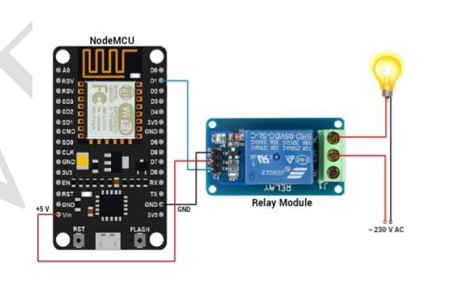

Fig 4.1 Interfacing Diagram of NODEMCU(ESP8266) with Ralay module

**HARDWARE REQUIREMENTS**

1. NodeMCU – 32-bit ESP8266 development board with Wi-Fi SoC.

2. Relay module

3. One 15W Bulb

4. One 9V DC Fan

* NODE MCU (ESP8266)

NodeMCU is an open source IoT platform, it includes firmware that runs on ESP8266 Wi-Fi module from Espressif Systems and hardware based on ESP-12 module. The term "NodeMCU" by default refers to firmware rather than development kits. NodeMCU firmware has been developed so that AT commands can be replaced by Lua scripts making life easier for developers. The ESP8266 is a low cost Wi-Fi chip with a full TCP / IP stack and microcontroller capability produced by the Chinese manufacturer Espressif, based in Shanghai. The figure shows the NodeMCU development board (ESP8266).

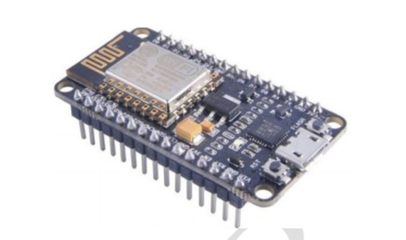

Fig 4.2 NODEMCU (ESP8266) Development Board

FEATURES OF NODE MCU (ESP8266):

Node MCU is open source and it is available in market. It is interactive . It is programmable. It is low cost. It is simple. It is smart. It is Wi-Fi enabled. USB-TTL is included.

SPECIFICATIONS OF NODE MCU (ESP8266):

1. Developer: ESP8266 Opensource Community

2. Type: Singleboard microcontroller

3. Operating system: XTOS

4. CPU: ESP8266

5. Memory: 128kBytes

6. Storage: 4MBytes

7. Power By: USB

8. Power Voltage: 3v, 5v (used with 3.3v Regulator inbuilt on Board using Pin VIN)

9. Code: Arduino Cpp

10. IDE Used: Arduino IDE

ADVANTAGES OF NODE MCU (ESP8266):

1. Low energy consumption: It consumes less power and produces more efficiency.

2. Integrated support for WIFI network: It supports cloud network like Wi-Fi.

3. Reduced size of the board: The size of PCB board is less.

4. Low Cost: It is cheap and reliable.

PIN DIAGRAM OF NODE MCU:

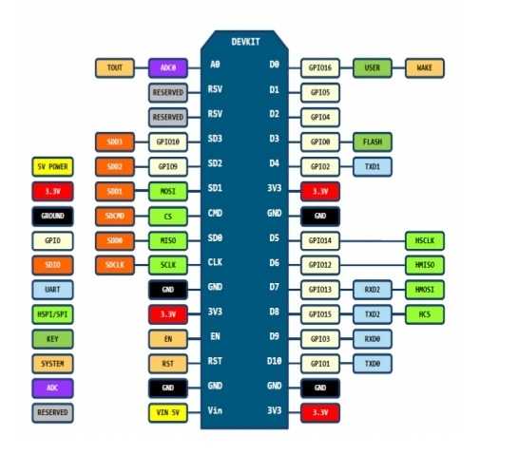

Fig 4.3 Pin Diagram of Node MCU

PROGRAMMING NODE MCU:

Install the current upstream Arduino IDE at the 1.8 level or later. The current version is at the Arduino website. Start Arduino and open Preferences window.Enter https://arduino.esp8266.com/stable/pac kage_esp8266com_index.json into additional Board Manager URLs field. You can add multiple URLs, separating them with commas.

After completion, data cable of your mobile phone. Used in To Connect ESP8266 MCU NODE with PC.After Install Drivers if Needed.Check Which Number Is Assigned To your Board.Open Arduino IDE. Open Boards Manager from Tools > esp8266 Modules platform and select NodeMCU1.0(ESP-12E Module) board from Tools.

• Upload Using: Serial

• CPU Frequency: 80 MHz

• Flash Size: 4M

• Upload Speed: 115200

• PORT: Select Assign Port Only.

Upload Code.

* Specifications:RELAY MODULE

A 4-channel relay interface board allows us to control various devices and other equipment Node MCU ESP8266 with large current. It can be directly controlled by microcontroller (Arduino, Node MCU, Raspberry Pi, 8051, AVR, PIC, DSP, ARM, ARM, MSP430, TTL logic).

• 4-channel relay interface card, each requiring 15-20mA driver current

• Both controlled by an input voltage of 12 V and 5 V

• Equipped with high current relay, AC250V 10A; DC30V 10A

• Standard interface which can be controlled directly by microcontroller.

• Opto-isolated inputs

• LED indicating the state of the relay output.

A relay is an electromagnetic switch. It is activated when a small current of a few microamperes is applied. Typically, a relay is used in a circuit as a type of switch, a circuit breaker. There are different types of relays and they operate at different voltages. When building a circuit, the voltage that will drive it must be taken into account. In this system, the relay circuit is used to turn on / off the devices. The high / low signal is provided by the NodeMCU microcontroller. When the relay of a device receives a low voltage, it turns off and when it receives a high voltage, it turns on. The relay circuit is to drive four devices in the home automation system. The number of luminaires can be changed according to user needs.

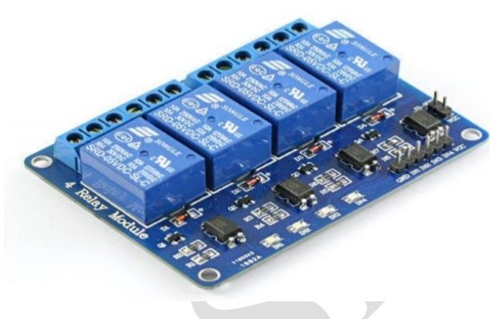

Fig 4.4 CHANNEL RELAY

**ADVANTAGES:**

1. Relays can switch AC and DC, transistors can only switch DC.

2. Relays can high voltages, transistors cannot.

3. Relays are a better choice for switching large currents(>5A).

4. Relays can switch many contacts at once.

**PIN DESCRIPTION**

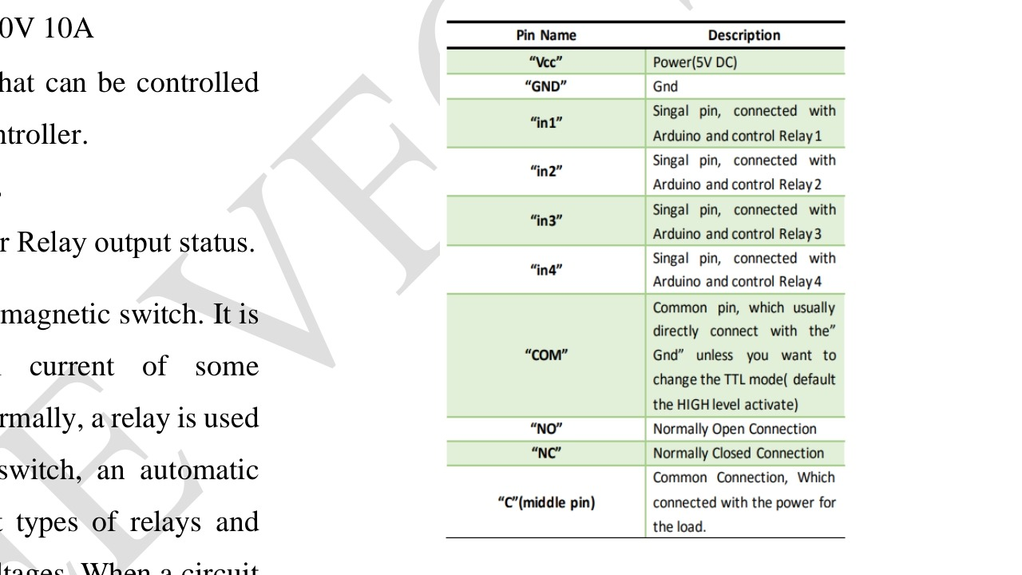

Table 4.1 Pin description of 4-Channel Relay

**SOFTWARE REQUIREMENTS**

1. Google assistant application

2. IFTTT Service.

3. Arduino IDE

* **GOOGLE ASSISTANT**

Google Assistant is artificial intelligence-based virtual assistant software that allows its users to control all applications on their device. It allows users to control and control most of the apps on their devices using voice commands. This provides more convenience for users as they only need to control all of the voice control from the Google Assistant. The figure shows the Google Assistant.

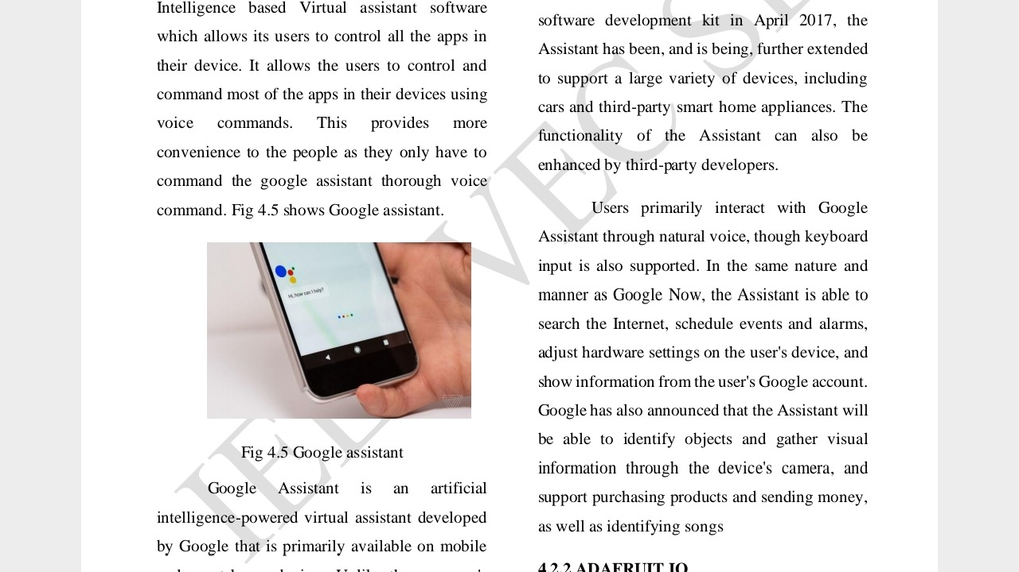

**Fig 4.5 Google assistant**

Google Assistant is an artificial intelligence powered virtual assistant developed by Google and primarily available on mobile and smart home devices. Unlike the company's old virtual assistant, Google Now, the Google Assistant can engage in two-way conversations. Assistant debuted in May 2016 as part of Google's Allomessaging app and its Google Home voice-activated speaker. After a period of exclusivity on Pixel and Pixel XL smartphones, it started rolling out to other Android devices in February 2017, including third-party smartphones and Android Wear (now Wear OS), and was released as standalone app on iOS. Operating system in May 2017. Along with the announcement of a SDK in April 2017, the Assistant has been and continues to expand to support a wide variety of devices, including cars and third-party smart devices. The functionality of the wizard can also be improved by external developers. Users primarily interact with the Google Assistant through a natural voice, although keyboard input is also supported. Similar to Google Now, Assistant can search the internet, schedule events and alarms, adjust hardware settings on the user's device, and view the user's Google Account information. Google also announced that the assistant will be able to identify objects and collect visual information through the device's camera, and support the purchase of products and sending money, as well as identifying songs.

• IFTTT

If This Then That, also known as IFTTT, is a free web service for creating strings of simple conditional statements, called applets. An applet is triggered by changes that occur in other web services such as Gmail, Facebook, Telegram, Instagram, or Pinterest. For example, an applet can send an email if the user tweets using a hashtag, or copy a photo on Facebook to a user's archive if someone tags a user in a photo. IFTTT is an initialization of "If This Then That. In addition to the web app, the service runs on iOS and Android. IFTTT users have created around 20 million recipes every day. All of the features in the suite of Do applications have integrated into a redesigned IFTTT application.

* ARDUINO IDE

The Arduino Integrated Development Environment (IDE) is a cross-platform application (for Windows, macOS, Linux) that is written in the Java programming language. It is used to write and load programs on Arduino compatible boards, but also, with the help of third-party cores, on third-party development boards. The source code for the IDE is released under the GNU General Public License, version 2. The Arduino IDE supports C and C ++ languages ​​using special code structuring rules. The Arduino IDE provides a Wiring Project software library, which provides many common input and output procedures. User-written code requires only two basic functions, to start the sketch and the main program loop, which are compiled and linked with a main () program stub into a cyclic executable program with the string d 'GNU tools, as well included with the IDE distribution. The Arduino IDE uses the avrdude program to convert executable code into a hexadecimal encoded text file that is loaded onto the Arduino board using a loader program in the board's firmware.

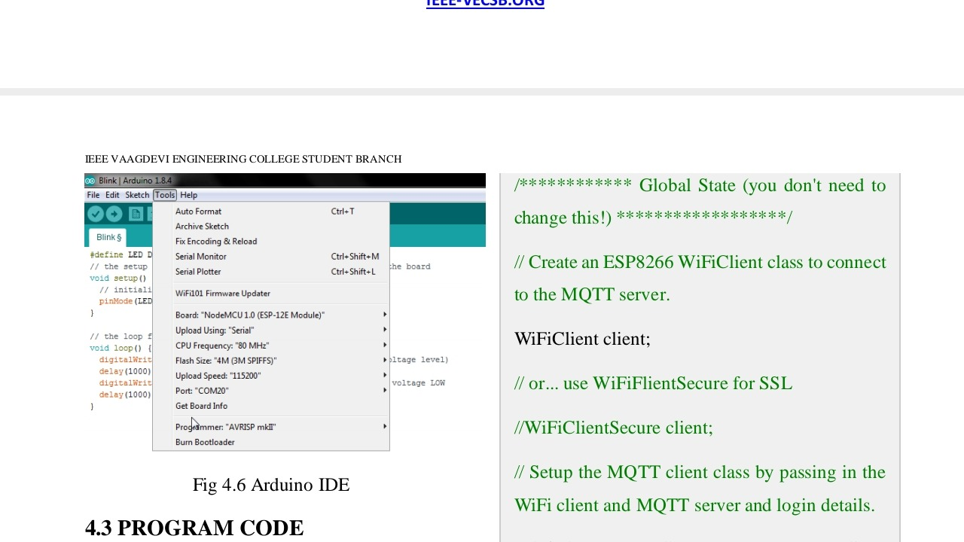

**Fig 4.6 Arduino edit window**

**CHAPTER 05**

**WORKING**

We will first give you Google Assistant commands such as "Turn on the light." This command therefore goes to IFTTT. Then it will check the orders registered in IFTTT. Then it will go to the Webhooks. Then in the webhooks it will look for the IP address of the Blynk server and our Blynk single sign-on token. Then it will look for the update command, like turn off the light or turn on the light. Then it goes to Blynk server and then to Node MCU over Wi-Fi using the authentication token. Next, Node MCU will perform the required action that was provided by the client at the start. Then it will generate the response and pass it to the Blynk server. From there it goes to Webhooks and IFTTT. Then from IFTTT the response will go to the Google Assistant (client) which has been configured in the IFTTT applet. When connecting the bulb with the relay module, one of the wires of the bulb will connect directly to the power supply, the other wire of the bulb will be delivered to the power supply through the relay module.

**CHAPTER 06**

**6.1 ADVANTAGES**

1. It reduces the Human Task: Work done by humans can be reduced with the help of this project.
2. It saves time for users and they can utilize that time in implementing other productive tasks.
3. It helps in managing all the Home Devices from a single place.
4. Maximizing the Home Security.
5. Increasing the flexibility for new devices.
6. Improving the Functionality of Home Appliances.

**6.2 LIMITATIONS**

1. It will not work without a net.

2. Hang on your mobile.

3. Maximum battery use.

4. Heat your mobile.

5. High data use.

**CHAPTER 07**

**RESULT AND DISCUSSION**

In this project, voice commands are given to the Google Assistant. Household appliances such as light, bulb, fan, motor, etc. They are controlled remotely by voice commands. This project is a wireless way to operate devices using Android mobile devices.

Fig 7.1 Outputs

**CHAPTER 08**

**CONCLUSION AND FUTURE WORK**

**FUTURE WORK**

There are a variety of improvements that could be made to this system to achieve greater detection and detection accuracy.

a) There are many other sensors that can be used to increase the security and control of the home, such as the pressure sensor that can be placed outside the home to detect that someone is entering the home. .

b) Change the form of automatic notifications using GSM module to make this system more professional.

c) A smart garage which can measure the length of the car and choose the block to put the car in and which will drive the car through the garage to make it easier for the owner to park in his garage.

**CONCLUSION:**

In this project, voice commands are given to the Google Assistant. Voice commands for the Google Assistant have been added through the IFTTT website and the Adafruit account is linked to it as well. In this home automation, the user gave commands to the Google Assistant. Household appliances such as light bulb, fan and motor etc. are controlled according to the given commands. The commands given through the Google Assistant are decoded and then sent to the microcontroller, which controls the relays. The device connected to the respective relay is activated or deactivated according to users' request to the Google Assistant. The microcontroller used is NodeMCU (ESP8266) and the communication between the microcontroller and the application is established via Wi-Fi (Internet). There has been tremendous growth in the home automation industry and many large companies have taken the opportunity to work with IFTTT to provide a stylish way to connect families to their homes. Consumers are looking to protect their home environment in today's unpredictable world, and the new home automation service gives them the peace of mind they need to protect the well-being of their families. This project is about wireless home automation using Android mobile devices which helps us to implement such a fantastic system in our home at a very reasonable price using cost effective devices. Thus, it overcomes many problems such as cost, rigidity, safety, etc. In addition, it will offer greater benefits such as reducing our energy costs, improving home security. In addition, it is very comfortable to use and will improve the comfort of our home. The project came up with the idea of ​​smart homes that could support many home automation systems. The programming language C # and the Node microcontroller were used to connect the sensor circuit to the home. In addition, in home automation and building systems, the use of wireless technologies offers several advantages that cannot be achieved by using a wired network.

1) Reduced installation costs.

2) Easy to set up, install and cover.

3) System scalability and easy expansion.

4) Aesthetic advantages.

5) Integration of mobile devices.

**APPLICATIONS**

• Lighting control system

• Control of household appliances with a smart grid

• Indoor positioning systems

• Home automation for the elderly and disabled

**REFERENCES**

[1]. Tan, Lee and Soh – “Internet based Monitoring of Distributed Control Systems”, - Energy and power Engineering. Publisher: IEEE Transactions on Education, Place: New Jersey, Country: USA, Year: 2002, Vol: 45, Iss. No. 2., pp. 128-134.

[2]. Potamitis, I., Georgila, K. Fakotakis, N., &Kokkinakis, G – ‘An Integrated system for smarthome control of appliances based on remote speech interaction’,- 8 th European conference on speech and communication technology, Publisher: World Journal control science and Engineering, Place: Geneva, Country: Switzerland, Year: 2003, Vol. No: 2, Iss. No.1, pp. 2197-2200.

[3]. S. M. Anamul Haque, S. M. Kamruzzaman and Md. Ashraful Islam – ‘A System for Smart Home Control of Appliances Based on Time and Speech Interaction’,- Proceedings of 4th International Conference on Electrical Engineering, Place: Bhubaneshwar, Country: India, Year:2006., pp.128 to 131.

[4]. N. P Jawarkar, V. Ahmed, S.A. Ladhake, and R.D Thakare – ‘Micocontroller based Remote monitoring using mobile phone through spoken commands’,- Journal of networks, Publisher: World Journal control science and engineering, Place: Lagos, Country: Nigeria, Year:2008, Vol. No.:3, Iss. No.2, pp.58 to 83.

[5]. Prof. Era Johri– ‘Remote Controlled Home Automation using Android application via Wi-Fi connectivity’, - International Journal on Recent and Innovation and recent trends in computing and communication, Publisher: World Journal control science and engineering, Place: North Dakota, Country: USA, Year: 2012, Vol. No.:3, Iss. No.3, pp.2321 to 8169.

**WEBSITES**

https://ifttt.com/discover https://www.pocketlini.com/SmartHome/ SmartHomenew https://nodemcu.readthedocs.io/en/master https://iobytes.wordpress.com/nodemcuin out/ https://assistant.google.com/intl/en_in/ https://www.arduino.cc/en/Guide/Environment

**REFERENCE BOOKS**

1. Internet of things – A Hands-on Approach, ArshdeepBahga and Vijay Madishetti, University press, 2015, ISBN: 9788173719547

2. Advanced Microprocessors and Peripherals – A. K. Ray and K. M. Bhurchandani, MHE, 2nd edition, 2006.

3. Modern digital electronics – RP Jain – 4/e – MC GRAW HILL EDUCATION, 2010. 4. Electronics devices and circuits – Salivahanan, MC GRAW HILL EDUCATION, 4th edition, 2010.